WEEK 1 : COGNIZANT FSE HANDS-ON EXERCISES
Exercise 1: Implementing the Singleton Pattern
Logger.java
public class Logger
{
private static Logger instance;
private Logger() {
}
public static Logger getInstance()
{
if (instance == null)
{
instance = new Logger();
}
return instance;
}
public void log(String message)
{
System.out.println(message);
}
}
SingleTonTest.java
public class SingletonTest {

public static void main(String[] args) {

Logger logger1 = Logger.getInstance();
Logger logger2 = Logger.getInstance();

logger1.log("Logging from Instance 1");
logger2.log("Logging from Instance 2");

if (logger1 == logger2)
{
System.out.println("Only one Logger instance exists.");
} else
{
System.out.println("Multiple instances created.");
}
}
}

Output:
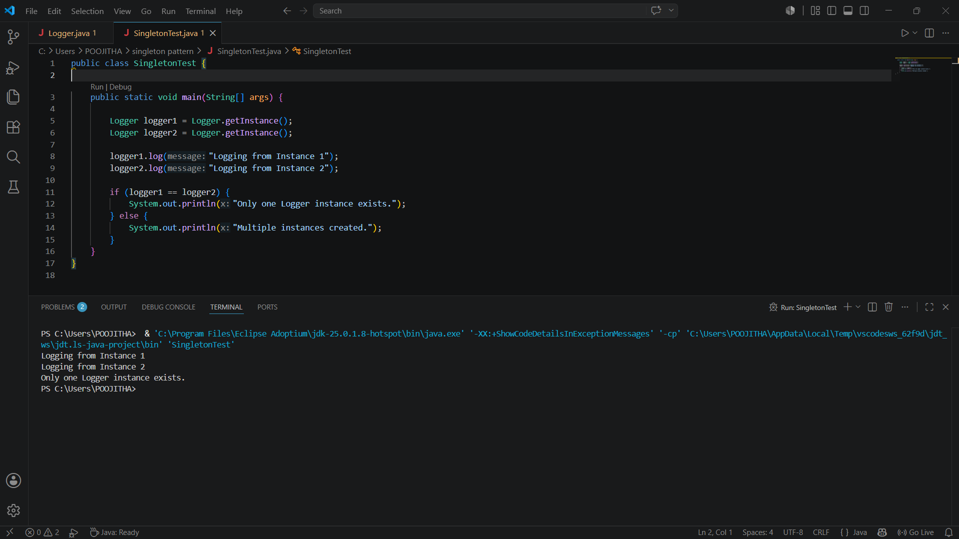

Exercise 2: Implementing the Factory Method Pattern
Document.java
public interface Document {
void open();
}

DocumentFactory.java
public abstract class DocumentFactory
{
public abstract Document createDocument();

public void create() {
Document document = createDocument();
document.open();
}
}
ExcelDocument.java
public class ExcelDocument implements Document {

@Override
public void open() {
System.out.println("Excel Document Created");
}
}
ExcelDocumentFactory.java
public class ExcelDocumentFactory extends DocumentFactory {

@Override
public Document createDocument() {
return new ExcelDocument();
}
}
FactoryMethodTest.java
public class FactoryMethodTest {

public static void main(String[] args) {

DocumentFactory word = new WordDocumentFactory();
word.create();

DocumentFactory pdf = new PdfDocumentFactory();
pdf.create();

DocumentFactory excel = new ExcelDocumentFactory();
excel.create();
}
}
PdfDocument.java
public class PdfDocument implements Document {

@Override
public void open() {
System.out.println("PDF Document Created");
}
}
PdfDocumentFctory.java
public class PdfDocumentFactory extends DocumentFactory {

@Override
public Document createDocument() {
return new PdfDocument();
}
}
WordDocument.java
public class WordDocument implements Document
{
@Override
public void open()
{
System.out.println("Word Document Created");
}
}
WordDocumentFactory.java
public class WordDocumentFactory extends DocumentFactory {

@Override
public Document createDocument()
{
return new WordDocument();
}
}

Output:

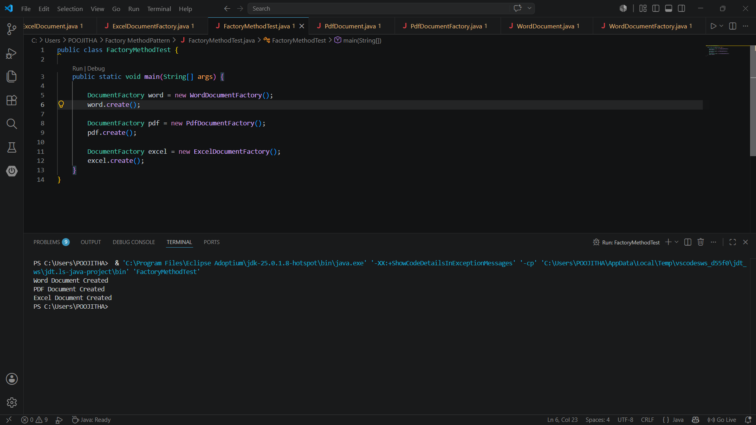

Exercise-3:E-commerce Platform Search Function
Product.java
public class Product {

int productId;
String productName;
String category;

public Product(int productId, String productName, String category) {
this.productId = productId;
this.productName = productName;
this.category = category;
}

public void display() {
System.out.println(productId + " " + productName + " " + category);
}
}
SearchTest.java
import java.util.Arrays;
import java.util.Comparator;
public class SearchTest
// Linear Search
public static Product linearSearch(Product[] products, String name) {

for (Product product : products) {
if (product.productName.equalsIgnoreCase(name)) {
return product;
}
}
return null;
}
// Binary Search
public static Product binarySearch(Product[] products, String name) {
int left = 0;
int right = products.length - 1;
while (left <= right) {
int mid = (left + right) / 2;
int compare = products[mid].productName.compareToIgnoreCase(name);

if (compare == 0) {
return products[mid];
}
if (compare < 0) {
left = mid + 1;
} else {
right = mid - 1;
}
}
return null;
}
public static void main(String[] args) {
Product[] products =
new Product(101, "Laptop", "Electronics"),
new Product(102, "Mobile", "Electronics"),
new Product(103, "Shoes", "Fashion"),
new Product(104, "Watch", "Accessories"),
new Product(105, "Book", "Education")
};
System.out.println("Linear Search");
Product result1 = linearSearch(products, "Shoes");
if (result1 != null) {
result1.display();
} else {
System.out.println("Product Not Found");
}

Arrays.sort(products, Comparator.comparing(p -> p.productName));

System.out.println();

System.out.println("Binary Search");

Product result2 = binarySearch(products, "Shoes");

if (result2 != null) {
result2.display();
} else {
System.out.println("Product Not Found");
}

System.out.println();

System.out.println("Time Complexity Analysis");

System.out.println("Linear Search : Best O(1), Average O(n), Worst O(n)");
System.out.println("Binary Search : Best O(1), Average O(log n), Worst O(log n)");

System.out.println();

System.out.println("Binary Search is faster for large sorted datasets.");
System.out.println("Linear Search is suitable for small or unsorted datasets.");
}
}

Output:
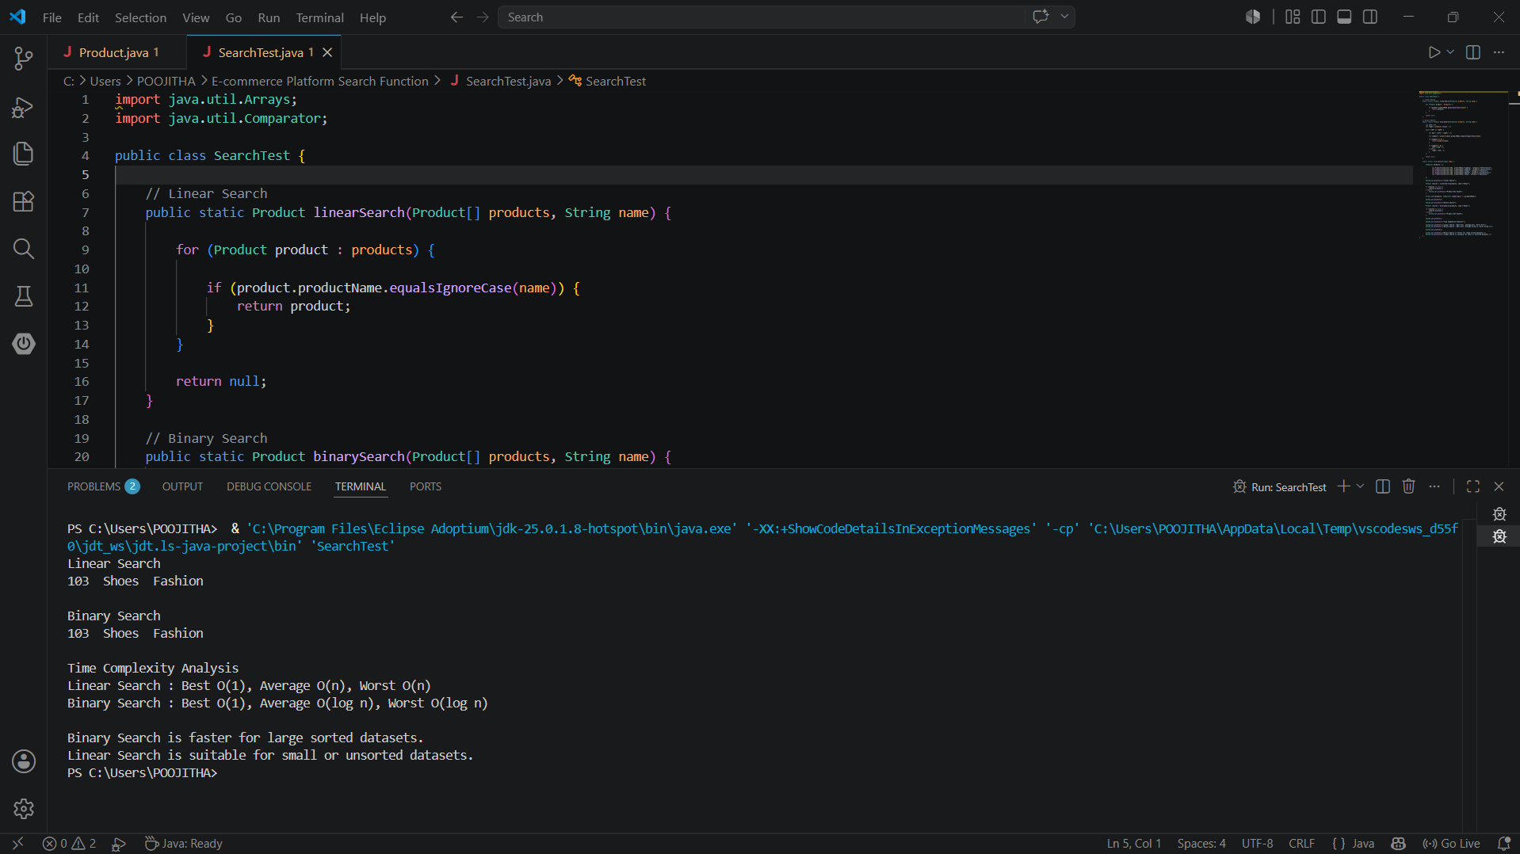
Exercise- 4: FinancialForecast
FinancialForcast.java
public class FinancialForecast {

public double predictFutureValue(double currentValue, double growthRate, int years) {

if (years == 0) {
return currentValue;
}

return predictFutureValue(currentValue * (1 + growthRate), growthRate, years - 1);
}
}
Main.java
public class Main {

public static void main(String[] args) {

FinancialForecast forecast = new FinancialForecast();

double currentValue = 10000;
double growthRate = 0.10; //10%
int years = 5;

double futureValue = forecast.predictFutureValue(currentValue, growthRate, years);

System.out.println("Current Value : " + currentValue);
System.out.println("Growth Rate : " + (growthRate * 100) + "%");
System.out.println("Years : " + years);
System.out.printf("Future Value : %.2f", futureValue);

System.out.println("\n");
System.out.println("Time Complexity : O(n)");
System.out.println("Optimization : Dynamic Programming or Memoization can be used");
}
}
Output:
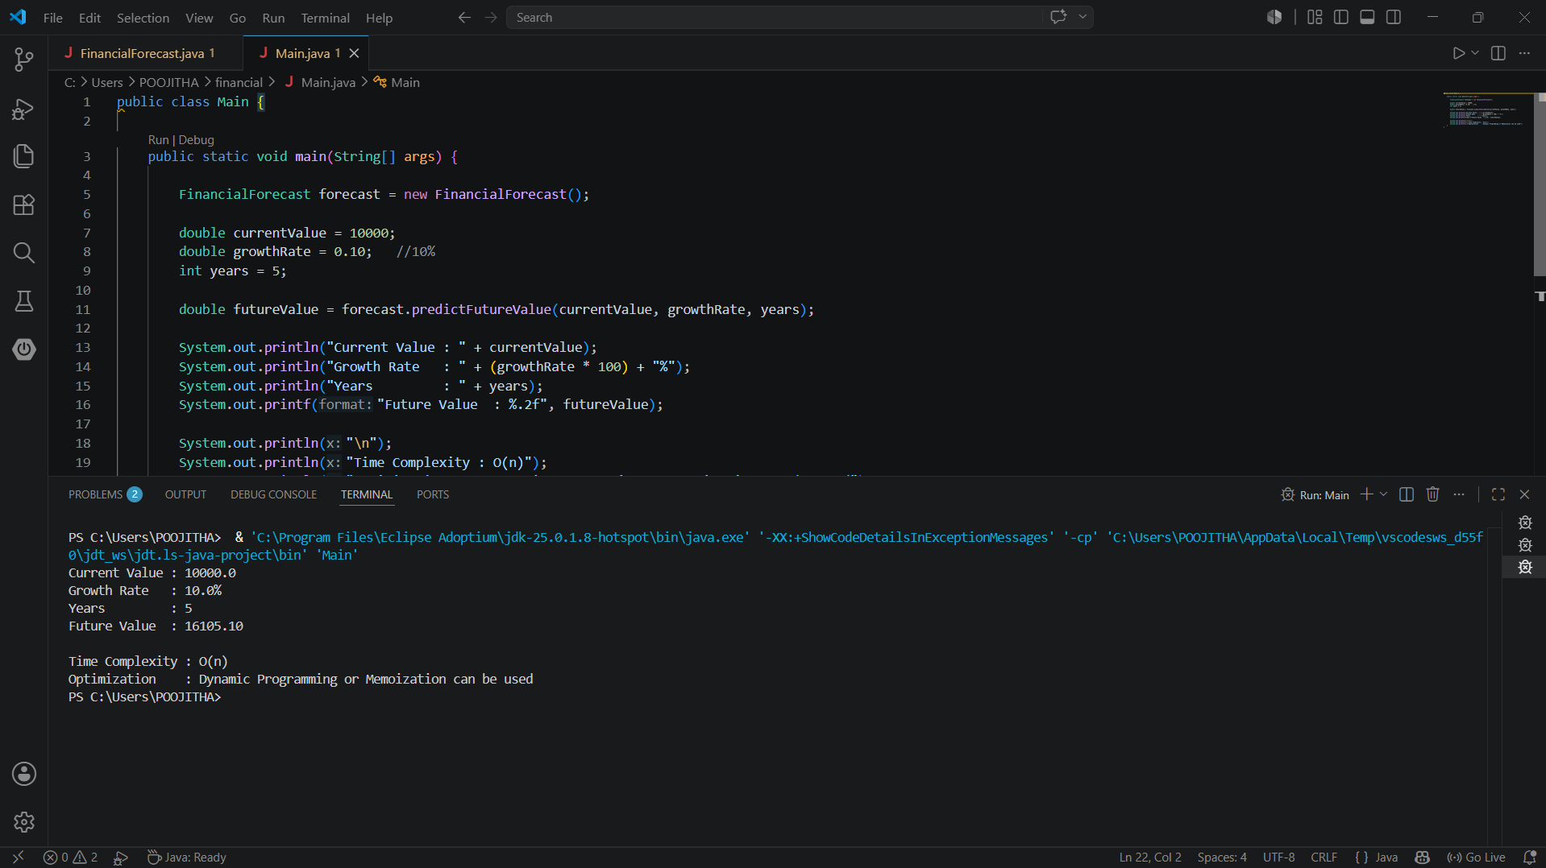
PL/SQL
Scenario 1: Apply 1% Interest Discount
BEGIN
FOR cust_rec IN (
SELECT CustomerID, Name, DOB
FROM Customers
) LOOP
DECLARE
v_age NUMBER;
BEGIN
v_age := FLOOR(MONTHS_BETWEEN(SYSDATE, cust_rec.DOB) / 12);

IF v_age > 60 THEN
UPDATE Loans
SET InterestRate = InterestRate - 1
WHERE CustomerID = cust_rec.CustomerID;

DBMS_OUTPUT.PUT_LINE(
'Discount applied for customer: ' || cust_rec.Name
);
END IF;
END;
END LOOP;
END;
/
Scenario 2: Set VIP Status
BEGIN
FOR customer_rec IN (
SELECT CustomerID, Balance
FROM Customers
) LOOP
IF customer_rec.Balance > 10000 THEN
UPDATE Customers
SET IsVIP = 'TRUE'
WHERE CustomerID = customer_rec.CustomerID;
END IF;
END LOOP;
DBMS_OUTPUT.PUT_LINE('VIP status updated successfully.');
END;
/
Scenario 3: Loan Reminder
BEGIN

FOR loan_rec IN (
SELECT l.LoanID,
c.Name,
l.EndDate
FROM Loans l
JOIN Customers c
ON l.CustomerID = c.CustomerID
WHERE l.EndDate <= SYSDATE + 30
) LOOP

DBMS_OUTPUT.PUT_LINE(
'Reminder: Loan ID ' || loan_rec.LoanID ||
' for customer ' || loan_rec.Name ||
' is due on ' ||
TO_CHAR(loan_rec.EndDate,'DD-MON-YYYY')
);
END LOOP;
END;
/

Output:
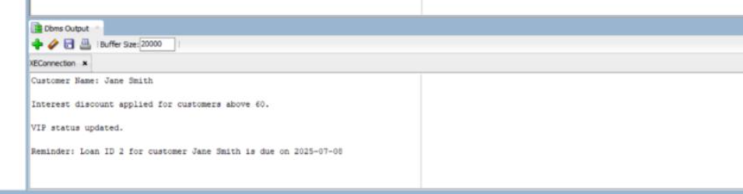

Exercise 3: Stored Procedures
Scenario 1: ProcessMonthlyInterest Procedure

CREATE OR REPLACE PROCEDURE ProcessMonthlyInterest IS
BEGIN
UPDATE Accounts
SET Balance = Balance + (Balance * 0.01)
WHERE AccountType = 'Savings';
DBMS_OUTPUT.PUT_LINE('Monthly interest applied to savings accounts.');
END;
/
BEGIN
ProcessMonthlyInterest;
END;
/
Scenario 2: UpdateEmployeeBonus Procedure

CREATE OR REPLACE PROCEDURE UpdateEmployeeBonus (
p_Department IN VARCHAR2,
p_BonusPercent IN NUMBER
) IS
BEGIN
UPDATE Employees
SET Salary = Salary + (Salary * (p_BonusPercent / 100))
WHERE Department = p_Department;
DBMS_OUTPUT.PUT_LINE('Bonus applied to department: ' || p_Department);
END;
/
Scenario 3: TransferFunds Procedure
CREATE OR REPLACE PROCEDURE TransferFunds (
p_SourceAccount IN NUMBER,
p_TargetAccount IN NUMBER,
p_Amount IN NUMBER
) IS
v_SourceBalance NUMBER;
BEGIN
SELECT Balance INTO v_SourceBalance
FROM Accounts
WHERE AccountID = p_SourceAccount;
IF v_SourceBalance < p_Amount THEN
RAISE_APPLICATION_ERROR(-20001, 'Insufficient balance.');
END IF;
UPDATE Accounts
SET Balance = Balance - p_Amount
WHERE AccountID = p_SourceAccount;
UPDATE Accounts
SET Balance = Balance + p_Amount
WHERE AccountID = p_TargetAccount;
DBMS_OUTPUT.PUT_LINE('Transfer completed.');
END;
/
BEGIN
TransferFunds(1, 2, 200);
END;

OUTPUT:
. 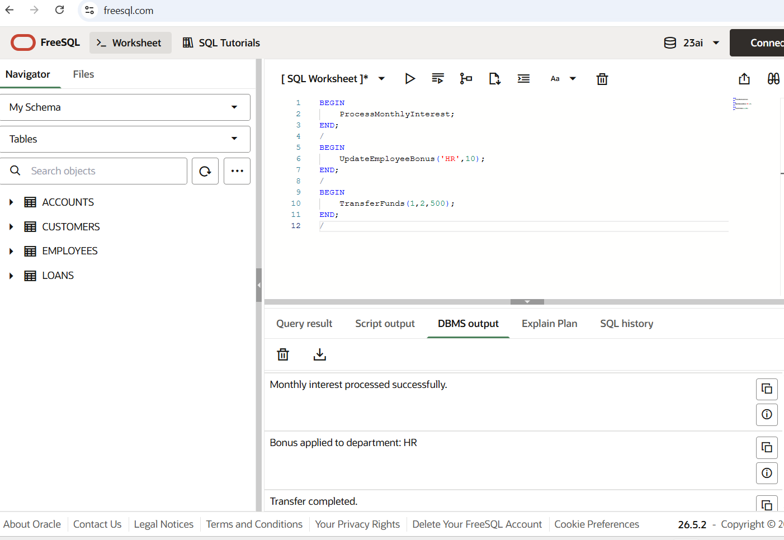

JUnit Testing Exercises:
Exercise 1: Setting Up JUnit
Calculator.java
package com.example;
public class Calculator {
public int add(int a, int b)
{
return a + b;
}
public int subtract(int a, int b) {
return a - b;
}
}

CalculatorTest.java
package com.example;
import org.junit.Test;
import static org.junit.Assert.*;
public class CalculatorTest
{
@Test public void testAdd()
{
Calculator calc = new Calculator();
int result = calc.add(2, 3);
assertEquals(5, result);
}
@Test public void testSubtract()
{
Calculator calc = new Calculator();
int result = calc.subtract(5, 3);
assertEquals(2, result);
}
}
Output:
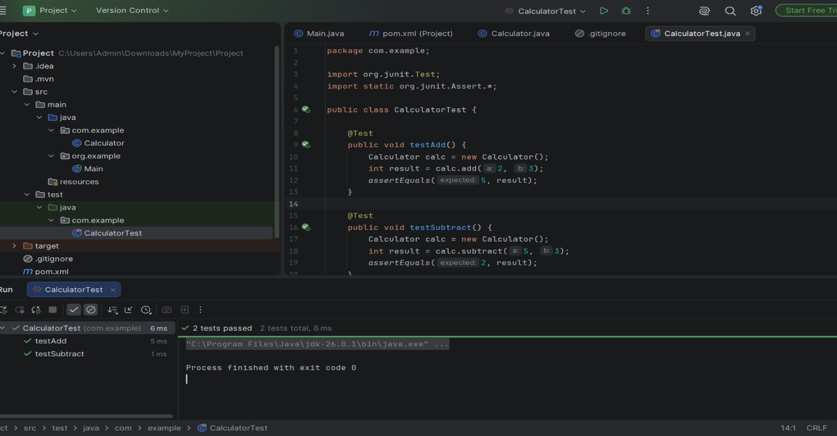
Exercise 3: Assertions in Junit
AssertionsTest.java
package com.example;
import org.junit.Test;
import static org.junit.Assert.*;
public class AssertionsTest {

@Test
public void testAssertions() {
assertEquals(5, 2 + 3);
assertTrue(5 > 3);
assertFalse(5 < 3);
assertNull(null);
assertNotNull(new Object());
}
}
Output
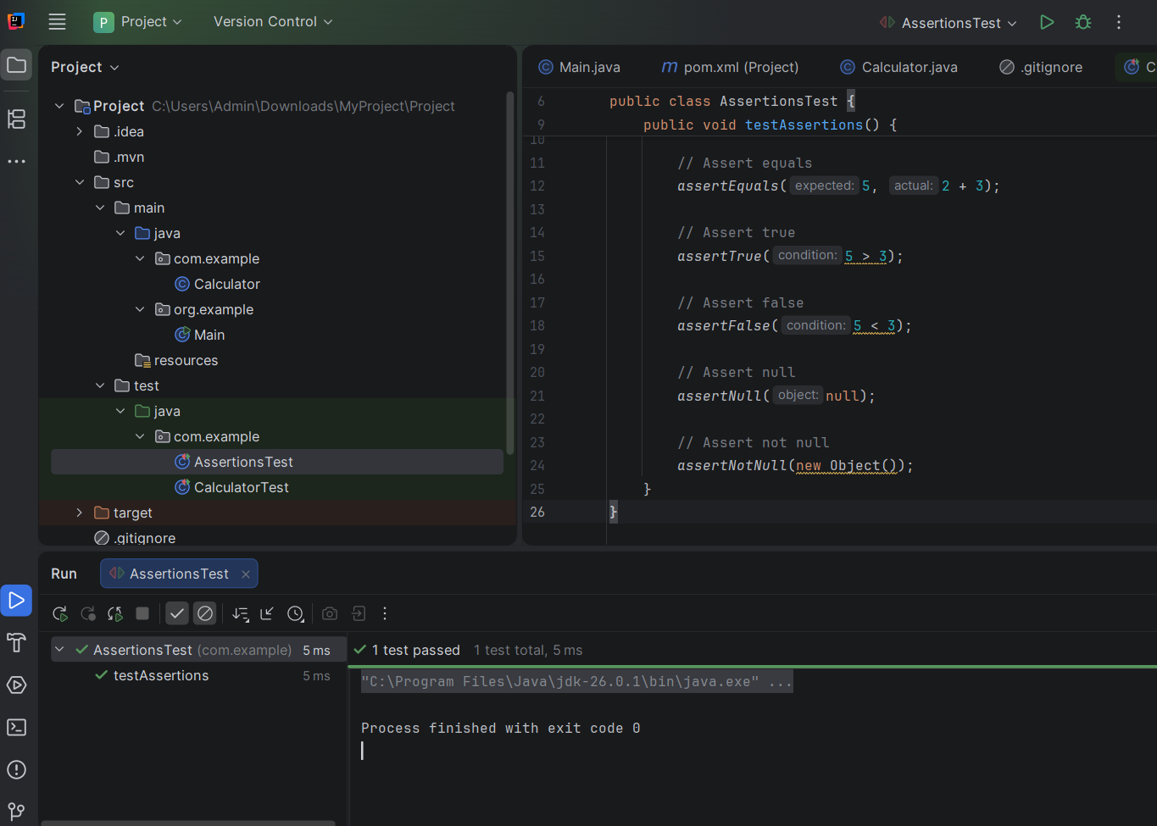

Exercise 4: Arrange-Act-Assert (AAA) Pattern, Test Fixtures, Setup and Teardown Methods in JUnit
CalculatorAaTest.java
package com.example;
import org.junit.After;
import org.junit.Before;
import org.junit.Test;
import static org.junit.Assert.*;
public class CalculatorAaTest {
private Calculator calculator;
@Before
public void setUp() {
calculator = new Calculator();
System.out.println("Setting up Calculator ");
}
@After
public void tearDown() {
System.out.println("Tearing down");
}
@Test
public void testAddUsingAAA() {
int a = 2;
int b = 3;
int result = calculator.add(a, b);
assertEquals(5, result);
}
@Test
public void testSubtractUsingAAA() {
int a = 10;
int b = 4;
int result = calculator.subtract(a, b);
assertEquals(6, result);
}

Output:
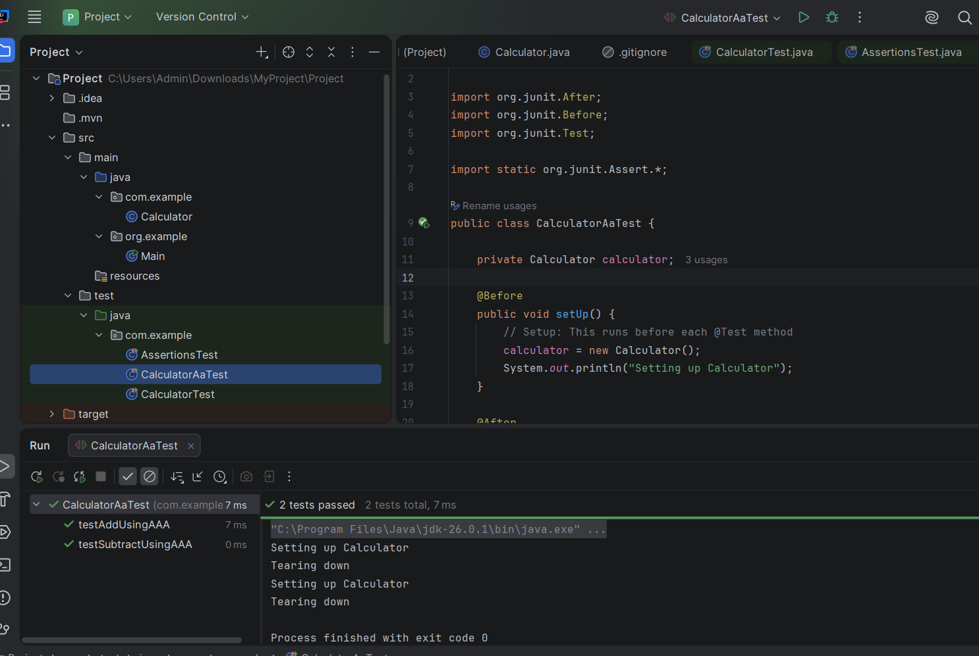

Exercise 1: Mocking and Stubbing
ExternalApi.java
package com.example;

public interface ExternalApi {
String getData();
}
MyService.java
package com.example;
public class MyService {
private ExternalApi api;
public MyService(ExternalApi api) {
this.api = api;
}public String fetchData() {
return api.getData();
}
}
MyServiceTest.java
package com.example;
import org.junit.Test;
import org.mockito.Mockito;
import static org.junit.Assert.*;
import static org.mockito.Mockito.*;
public class MyServiceTest {
@Test
public void testExternalApi() {
ExternalApi mockApi = Mockito.mock(ExternalApi.class);
when(mockApi.getData()).thenReturn("Mock Data");
MyService service = new MyService(mockApi);
String result = service.fetchData();
assertEquals("Mock Data", result);
}
}
OUTPUT:
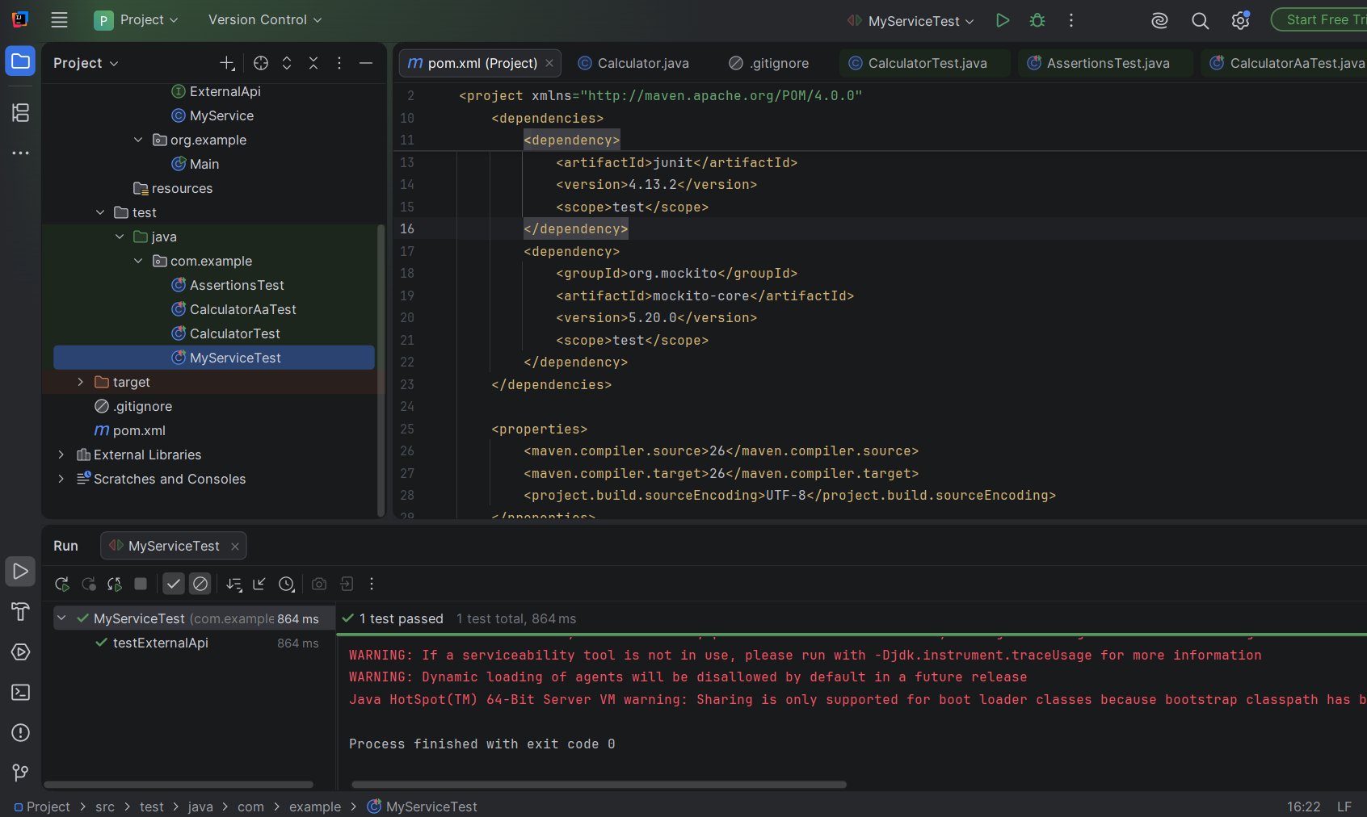
Exercise 2: Verifying Interactions
MyServiceVerifyTest.java
package com.example;
import static org.mockito.Mockito.*;
import org.junit.Test;
import org.mockito.Mockito;
public class MyServiceVerifyTest {

@Test
public void testVerifyInteraction() {
ExternalApi mockApi = Mockito.mock(ExternalApi.class);
MyService service = new MyService(mockApi);
service.fetchData();
verify(mockApi).getData();
}
}
OUTPUT

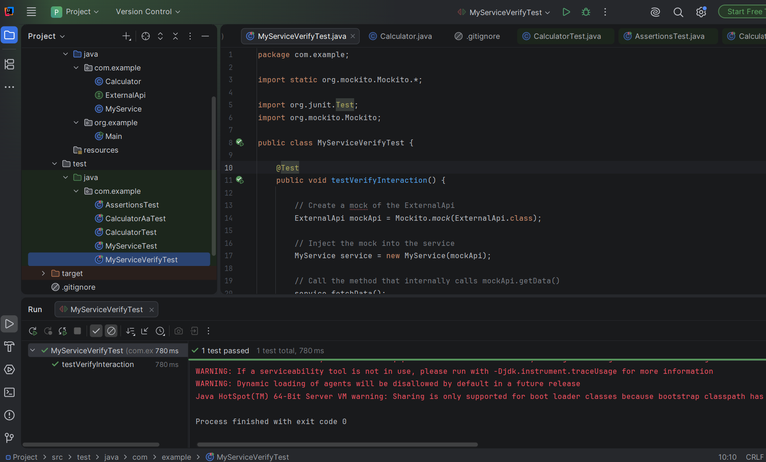

Logging using SLF4J:
Exercise 1: Logging Error Messages and Warning Levels
LoggingExample.java

package com.example;
import org.slf4j.Logger;
import org.slf4j.LoggerFactory;
public class LoggingExample
{
private static final Logger logger = LoggerFactory.getLogger(LoggingExample.class);
public static void main(String[] args) {
logger.error("This is an error message");
logger.warn("This is a warning message");
}
}
OUTPUT


